The Traveling Salesperson Problem

The Problem: As you approach the legal driving age you realize you need to start earning some money so that you won’t have to rely on your tricycle any more. You decide to go into business for yourself and start your own paper route. You start small, with only 3 customers. The following table represents the time, in minutes, for you to ride you tricycle between each of your customer homes, and yours.

 | Home | Aldo | Butch | Cassidy
Home | -- | 6 | 12 | 5
Aldo | 6 | -- | 8 | 9
Butch | 12 | 8 | -- | 13
Cassidy | 5 | 9 | 13 | --

Create a program that will display the shortest (time-wise) route for you to take.

Algorithms to code:
- Brute Force: Create a Tree diagram, analyzing all possible paths and pick the shortest.
- Nearest Neighbor: Starting from Home, go to the “nearest” neighbor (the neighbor whose house is closest), and then to that person’s “nearest” neighbor, and so on, until it is time to return home. No customer can be visited twice.
- Sorted-Edges / Cheapest-Link: Select paths one at a time, always selecting the “cheapest” path. Continue in this manner, unless picking a path will “close” your route (close a circuit) before reaching all your customers, or it will be a third path/edge chosen to a customer’s house.

(See Following Pages)

The user will select the algorithm to be used.

Your home and your customers are mathematically represented by a graph, or a network of vertices and edges connecting the vertices. One possible graph representing the above situation is pictured below:
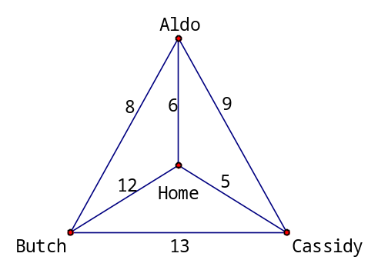

Upgrades:
- User selects start location.
- Not all locations are connected
- File I/O for larger networks.
Brute Force:
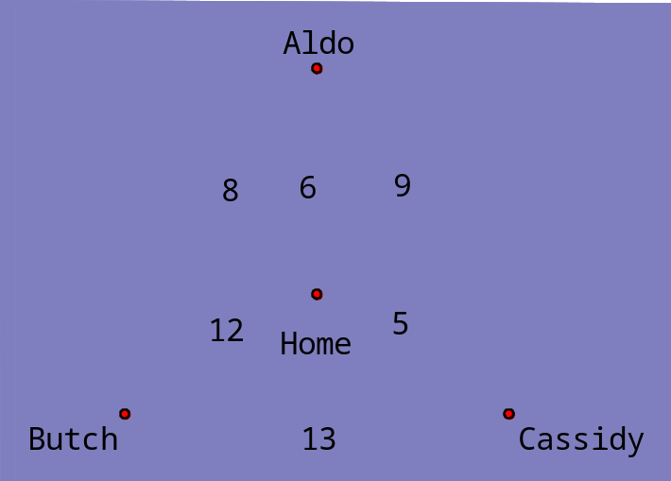

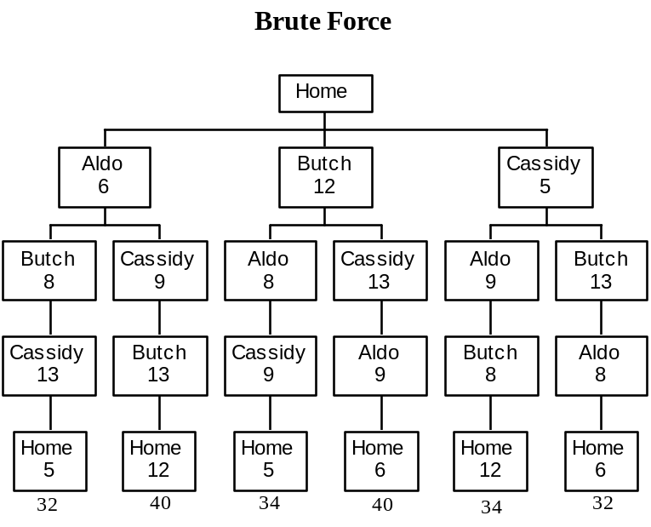

The first and last paths are the shortest, each taking 32 minutes.
Note that the order of H-A-B-C-H is the reverse of H-C-B-A-H

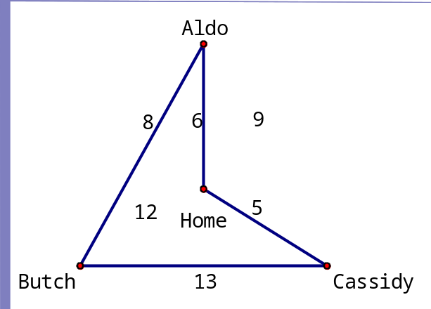
Nearest Neighbor:

Start at Home. The possible paths are 5, 6, and 12. 5 is the shortest, so we go to Cassidy: | 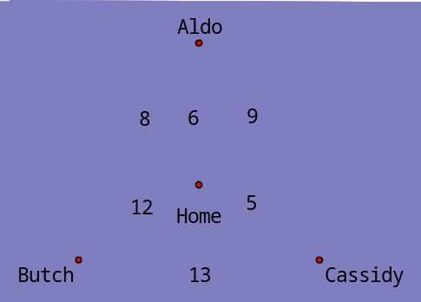
From Cassidy the possible paths are 9 and 13 (the 5 was already taken), so we go to Aldo. | 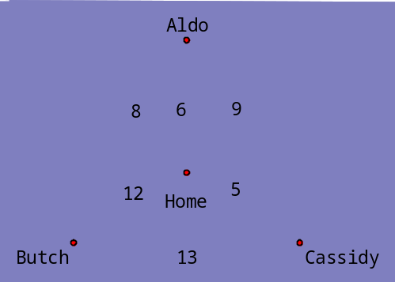
From Aldo the possible paths are 6 and 8 (the 9 was already taken). Since taking the 6 path brings us home without visiting Butch, we must take the 8. | 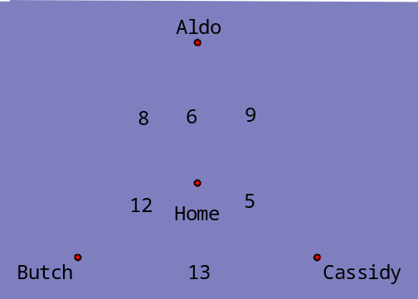
From Butch the 12 and 13 paths are available, but we’ve visited all the customers so we want to go home. | 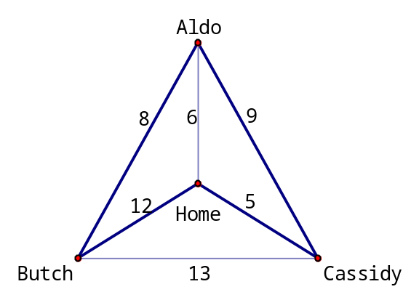

The Nearest-Neighbor Algorithm yields a path of H-C-A-B-H or H-B-A-C-H.
Note that these paths are 34 minutes long – this is not the optimal solution, but still a good solution.
Sorted-Edges / Cheapest Link:

Start by sorting the edges smallest to largest.  5  6  8  9  12  13 | 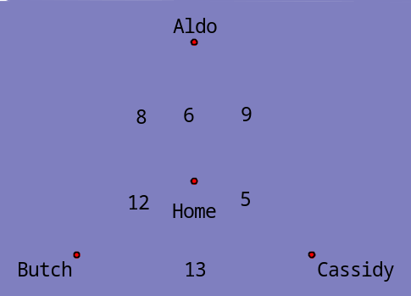
Go down the list, selecting the shortest available path that does not close a circuit (unless you’re done) and it is not the third path/edge leading to a customer/vertex.  5  6  8  9  12  13 | 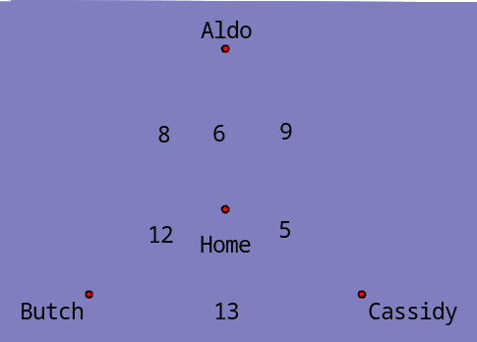
5  6  8  9  12  13 | 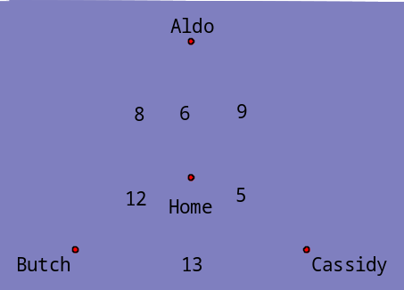
5  6  8  9  12  13 | 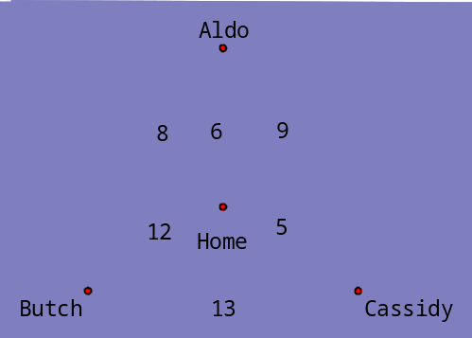
Note that 9 and 12 cannot be picked because they close of a circuit, each leaving a customer/vertex left out.  5  6  8  9  12  13 | 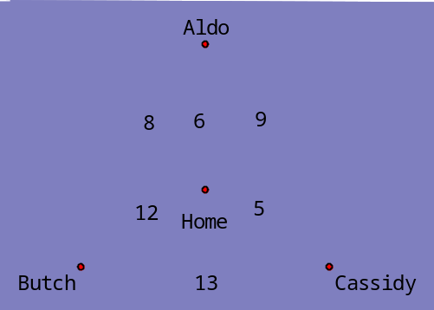
Note that this algorithm produced a path of H-A-B-C-H (or H-C-B-A-H) which takes 32 minutes and is our optimal path.

